https://www.jdoodle.com/embed/v0/69RB
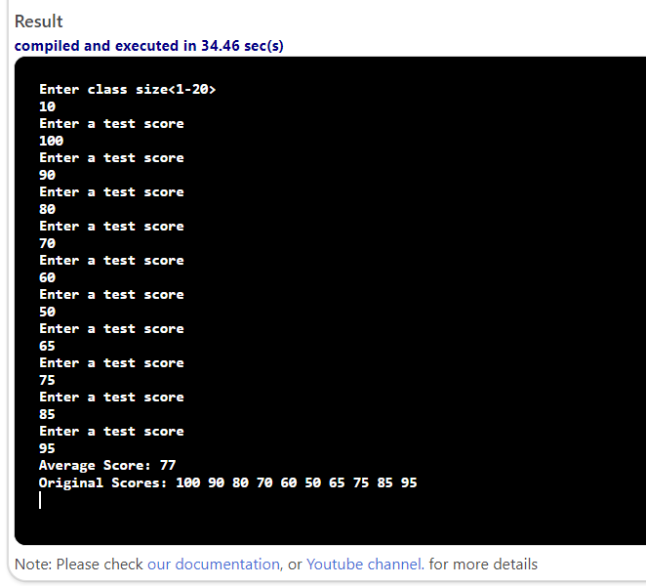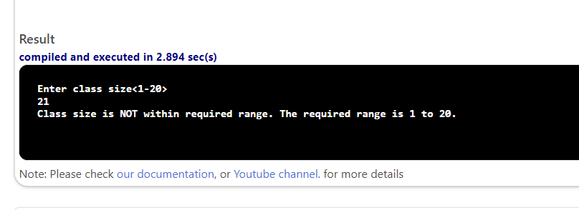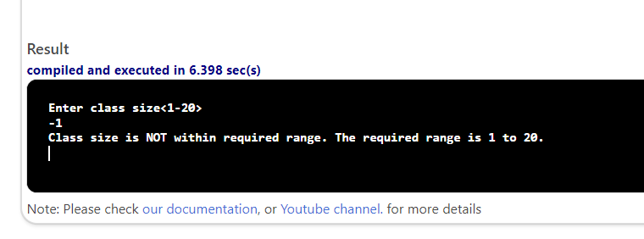

#include <iostream>
using namespace std;

// function declarations
void inputScores(double s[], int sLen);
double compAverage(double s[], int sLen);
void dispScores(double s[], int sLen);

int main()
{
double scores[20];
int classSize;
double sum = 0;
double average;
int i;
cout << "Enter class size<1-20>" << endl;
cin >> classSize;

if (classSize < 1 || classSize > 20)
{
cout << "Class size is NOT within required range. The required range is 1 to 20." << endl;
return 0;
}

inputScores(scores, classSize);

average = compAverage(scores, classSize);
cout << "Average Score: " << average << endl;
dispScores(scores, classSize);

return 0;
}

void inputScores(double s[], int sLen)
{
int i;
for (i = 0; i < sLen; i++)
{
cout << "Enter a test score" << endl;
cin >> s[i];
}

}

double compAverage(double s[], int sLen)
{
double sum = 0;
int i;
for (i = 0; i < sLen; i++)
{
sum = sum + s[i];
}
return sum / sLen;
}

void dispScores(double s[], int sLen)
{
int i;
cout << "Original Scores: ";
for (i = 0; i < sLen; i++)

{
cout << s[i] << " ";
}
cout << endl;
}

